Discussion on co-management as a means of improving local-scale outcomes for those inhabiting at local scales and presentation of a qualitative modelling work in progress
NI Governance working group
- Co-management: Stakeholder role typology
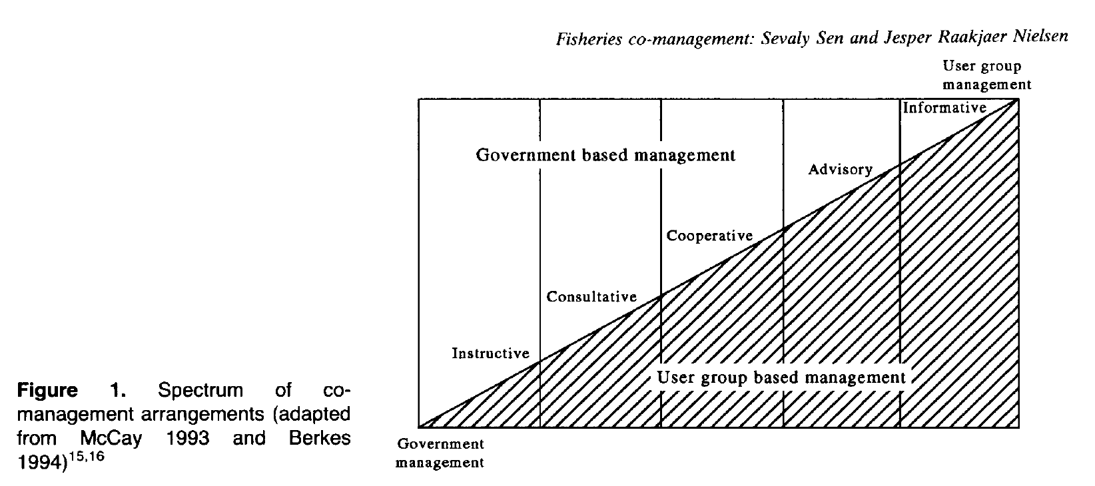
Taken from Sen and Nielsen. 1996. Fisheries co-management: a comparative analysis. Marine Policy

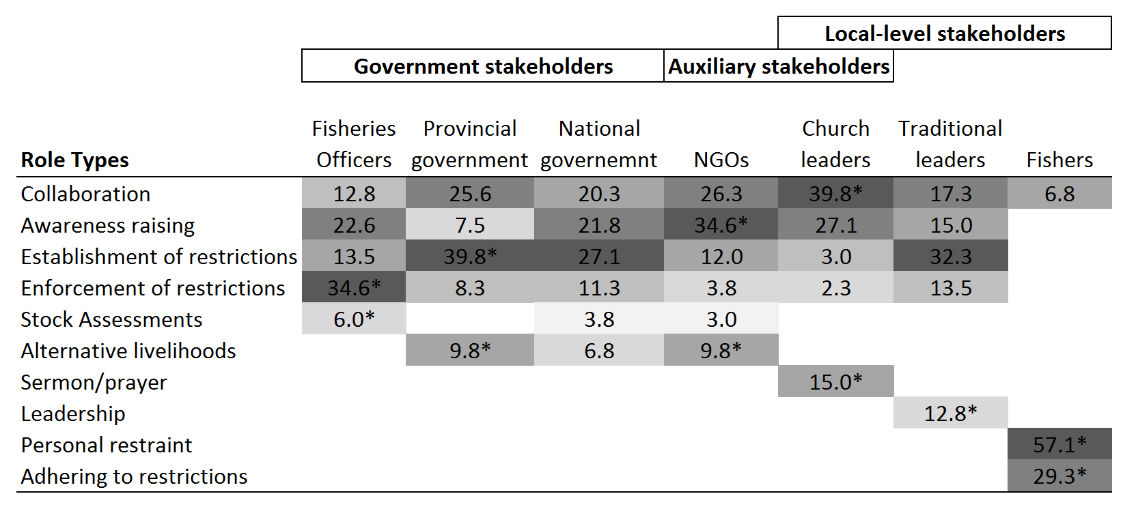
Table 2. Role types showing percentage of respondents that assigned particular roles to each of the stakeholder types. Gradient of shading from most frequently stated role (dark) to least frequently stated role (light) for each stakeholder type. Asterisks (*) denotes instances of the highest response frequency for each role among stakeholder types. For example, a greater proportion of respondents stated that the provincial government should establish restrictions compared to national government despite the most frequently stated role for national government being the establishment of restrictions. Collaboration includes ‘support’ of other stakeholder types. ‘Awareness’ refers to raising awareness. ‘Alternative livelihoods’ refers to developing alternate sources of incomes for fishers and fish traders. ‘Sermon/prayer’ refers to church leaders influencing fishers and fish traders through, for example, sermon and prayer to fish sustainably, and divine intervention to increase fish stocks.

- Qualitative modelling of large scale public policy
Background:
The federal government is developing a policy agenda for ‘the north’ (Green paper, white paper, and a large amount of investment).
Many policy decisions affect large scales (social, spatial, economic, biophysical etc.). These large scales contain, within their boundaries, more diverse landscapes and peoples than smaller scales. They are inevitable highly heterogeneous. Such scales are also inevitably more complex than, for example, local scales, such as individual electorates. Thus policy decisions are very complicated and likely to have perverse outcomes. Despite the drawbacks, federal policy focused on Northern Australia will not be localised, but continue to extend across vast regions.
Given this inevitability, it is important to understand contexts from a systems perspective. Systems approaches theoretically identify key variables (e.g. population growth, literacy) and how they interact. Developing systems models helps us to problematize issues for the north, identifying strengths and weaknesses in current systems, and how specific policies might affect systems. It also helps participants, in the modelling process, form a deeper and broader appreciation for the identified system. Such tools make policy decision-making less subjective and ideological and can be tracked through the policy cycle.
The aim of our book chapter is to improve the policy process by developing systems models for dominant points of tension in the policy landscape of northern Australia. Key points of tension identified by the CRN group are:
Big development
Big conservation
Indigenous wellbeing

To develop qualitative models of these three points of tension we will:
- Develop narratives for each to elucidate some of the underlying form and function (structure and process)
- Use expert elicitation to define system boundaries and build system models
- Assess, mathematically, the stability of the systems, and effects of potential policy, on system states.
- Review ways of ‘levering’ the systems for better outcomes.

It is expected that we will require expertise outside of the CRN to develop robust models.

